Vinita Ravivarma  
Professor Rodriguez

CS-330-11661-M01

January 15th, 2025

1-2 Assignment: Preparing the Development Environment

**Screenshot of the image:**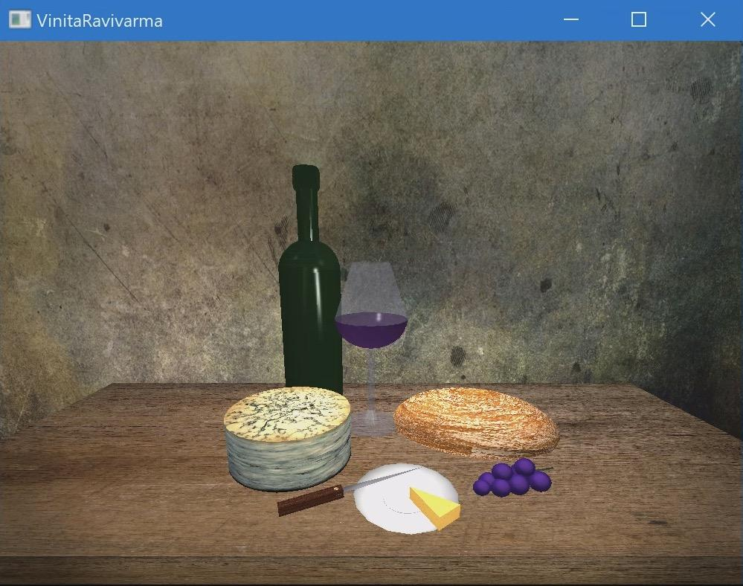

There are certain challenges that I experienced while opening and setting up OpenGL throughout the Module One Assignment. Some challenges I’ve faced were installation/configuration, compatibility/versioning, and debugging/troubleshooting. I followed the instructions for installation in which the OpenGL documentation was provided through any relevant tutorials, verified hardware and operating system compatibility, and used some techniques along with debugging tools specific to OpenGL. I also got help from my instructors or online communities such as the resources for any problems I encountered throughout this assignment. Overall, I looked for guidance by using the module resources and talking to my instructors about the way I do the work throughout an assignment.